**Acknowledgement**

|  |  |
| --- | --- |
| wine datASET  **BAN 620-Data Mining** | **Project report Submitted BY:**  Shanmukh Behara (ug8788)  Snigdha Enumulapally (xc2373)  Damoder Reddy Pannala (lz7285)  Sri Samhitha Pallelamudi (ti6266) |

We have taken a lot of effort into this project. However, completing this project would not have been possible without the support and guidance of a lot of individuals. We would like to extend our sincere thanks to all of them.

We would like to express our gratitude towards our Professor **Mr. Robert Treichler** for his support and guidance in accomplishment of our project on Data mining.

I would like to extend my deep appreciation to all my group members, without their support and coordination we would not have been able to complete this project.

Finally, I would like to thank my parents and friends for their constant support and encouragement.

**Contents:**

|  |  |  |  |  |  |
| --- | --- | --- | --- | --- | --- |
| 1 | WINE Overview | | | | |
| 2 | Introduction | | | | |
| 3 | Data Exploration | | | | |
|  | 3.1 | Bar Plots, Histograms, and Inferences | | | |
|  | 3.2 | Heatmap, Scatter Plots and Inferences | | | |
|  | 3.2 | Detecting Missing Values | | | |
| 4 | Data Preparation | | | | |
|  | 4.1 | Imputing NULL Values | | | |
|  | 4.2 | Detecting Outliers and Imputing | | | |
|  | 4.3 | Principal Component Analysis (PCA) | | | |
|  | 4.4 | K-Means Clustering | | | |
|  | 4.5 | Handling Imbalanced data | | | |
|  | 4.6 | Splitting Data | | | |
| 5 | Modeling | | | | |
|  | 5.1 | | Pipelines | | |
|  | 5.2 | | Classification for Wine Type | | |
|  |  | | 5.2.1 | Logistic Regression | |
|  |  | | 5.2.2 | Decision Tree | |
|  |  | | 5.2.3 | Random Forest | |
|  | 5.3 | | Prediction for Wine Quality | | |
|  |  | | 5.3.1 | | Linear Regression |
|  |  | | 5.3.2 | | Ridge Regression |
|  |  | | 5.3.3 | | Lasso Regression |
| 6 | Conclusion | | | | |

**1.WINE Overview**

**Wine** is an alcoholic drink typically made from [fermented](https://en.wikipedia.org/wiki/Fermentation_in_winemaking) [grapes](https://en.wikipedia.org/wiki/Grape). [Yeast](https://en.wikipedia.org/wiki/Yeast_in_winemaking) consumes the [sugar](https://en.wikipedia.org/wiki/Sugar) in the grapes and converts it to [ethanol](https://en.wikipedia.org/wiki/Ethanol) and [carbon dioxide](https://en.wikipedia.org/wiki/Carbon_dioxide), releasing [heat](https://en.wikipedia.org/wiki/Heat) in the process. Different varieties of grapes and [strains](https://en.wikipedia.org/wiki/Strain_(biology)) of yeasts are major factors in different styles of wine. These differences result from the complex interactions between the biochemical development of the grape, the reactions involved in [fermentation](https://en.wikipedia.org/wiki/Fermentation), the grape's growing environment ([terroir](https://en.wikipedia.org/wiki/Terroir)), and the wine production process.

Wine has been produced for thousands of years. The five countries with the largest wine-producing regions are in [Italy](https://en.wikipedia.org/wiki/Italian_wine), [Spain](https://en.wikipedia.org/wiki/Spanish_wine), [France](https://en.wikipedia.org/wiki/French_wine), [the United States](https://en.wikipedia.org/wiki/American_wine), and [China](https://en.wikipedia.org/wiki/Chinese_wine).

Wine is made in many ways from different fruits, with grapes being the most common. Types of wines from grapes are Red, White, Rose, Orange, Sparkling and Dessert.

Wine is usually made from one or more grape [varieties](https://en.wikipedia.org/wiki/Variety_(biology)) of the European [species](https://en.wikipedia.org/wiki/Species) [*Vitis vinifera*](https://en.wikipedia.org/wiki/Vitis_vinifera), such as [Pinot noir](https://en.wikipedia.org/wiki/Pinot_noir), [Chardonnay](https://en.wikipedia.org/wiki/Chardonnay), Cabernet Sauvignon, [Gamay](https://en.wikipedia.org/wiki/Gamay) and [Merlot](https://en.wikipedia.org/wiki/Merlot).

[Wine cellars](https://en.wikipedia.org/wiki/Wine_cellar), or wine rooms, if they are above-ground, are places designed specifically for the storage and aging of wine. Fine restaurants and some private homes have wine cellars.

There are a large number of occupations and professions that are part of the wine industry, ranging from the individuals who grow the grapes, prepare the wine, bottle it, sell it, assess it, market it and finally make recommendations to clients and serve the wine.

Wine has a variety of characteristics that are all very important to the overall quality of wine. **Basic characteristics are:**

**Acidity**: The acidity in a wine plays a very important role. Most wines are fairly acidic. You can tell how much acidity is in wine by how much you salivate after you drink it. The acidity will take crisp, zesty, and often create citrus or unripe fruit flavors.

**Sweetness**: Wines can range from bone dry to very sweet. Traditionally wines are made to be dry or off-dry with the exception of late-harvest and dessert wines. Sweetness can add body to a wine. A wine that is fruit forward is often confused with a sweet wine.

**Tannins**: Tannins can often be confused with the dryness of the wine because they dry out your mouth. They can taste bitter and herbaceous. Wines that have a good balance of tannins and acidity can age well. While most white wines are very low in tannins, you can test the amount of tannins in red wine by how much they dry out your mouth and the feeling of roughness it leaves behind in your mouth.

**Alcohol**: Typically, white wines have a lower alcohol level than red wines and some dessert wines can have up to 40% alcohol. Most white wines are in the 8-11% alcohol range while most red wines are in the 11-13% range.

**Body**: The level of body wine has is typically entirely dependent on the varietal of grape and the influence the winemaker’s practice has on the wine. The body of wine can typically be compared to the fat levels in milk. Light body wines will feel like you are drinking skim milk, while rich and full body wines will feel like you are drinking whole milk.

**2.Introduction**

Data has become a modern-day currency. Tremendous value and intelligence is being extracted from large, captured datasets (Big data) that has led to actionable insights through today’s world. It’s not just about storing data any longer, but capturing, preserving, accessing and transforming it to take advantage of its possibilities and the value it can deliver.

The dataset provided contains information on approximately 6,500 commercially available wines and the variables are the chemical properties of wine being sold.

It will definitely be interesting to analyze the physicochemical attributes of wine and understand their relationships and significance with wine quality and type classifications.

Here, we have two types of wine (Red & white).

**Main objectives:**

1. Predicting Quality of wine
2. Classification based on Wine Type

We are using Jupyter notebook in order to achieve the above-mentioned objectives.

**3.Data Exploration:**

**Understanding Attribute types and properties:**

We have 13 attributes mentioned below, among which we consider 1-12 attributes as input and 13th attribute Quality as an output whose score is in between 0-10.

Acid types and measures:

1. fixed acidity
2. volatile acidity
3. citric acid
4. pH

Salty measure:

1. chlorides

Sulphites:

1. free sulfur dioxide
2. total sulfur dioxide
3. Sulphates

Sweetness:

1. Residual Sugar

Body:

1. Density

Alcohol:

1. Alcohol

Classification attributes:

1. Type
2. Quality

**Importing Libraries:**

We are importing below libraries before getting started with the project. In most of the part of the project, we are using following library files in most of the cases:

* **Scikit-learn** which is a package that provides efficient versions of a large number of common algorithms. We are using Scikit-learn in this project for Preprocessing, Model Selection, Calculating errors, Decomposition, Pipeline etc.,
* We are using **Pandas** library for Data manipulation and Data Analysis.
* **Matplotlib** and **Seaborn** are used in most of the cases for plotting the graphs.

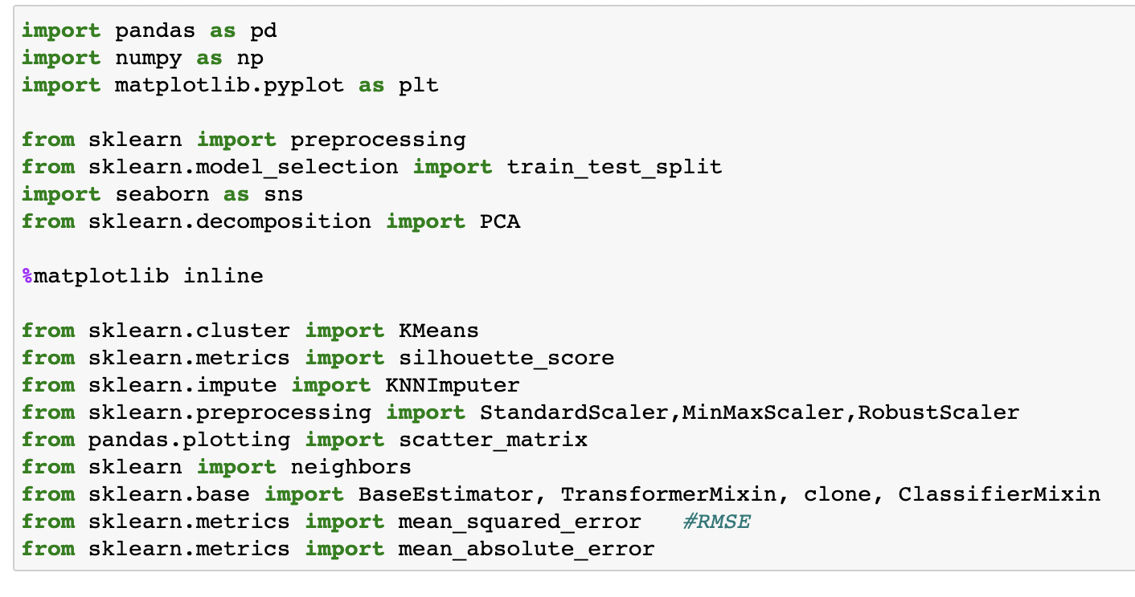

**Getting the info of attributes:**

Info() of a dataset provides us with Count of non-null values and data type of each attribute in dataset.

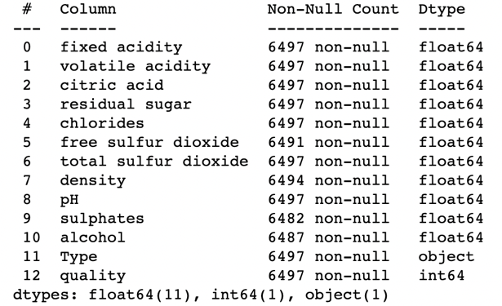

Checking first few rows of the dataset and the number of rows and columns available in the dataset

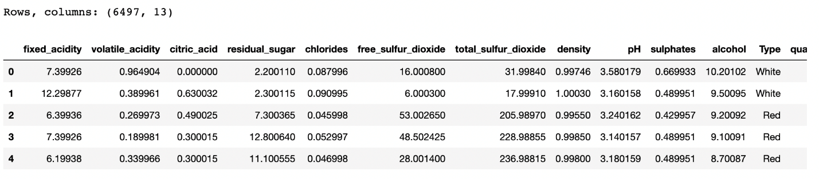

**Describing attributes:**

To get the summary of statistics, let us describe the data. Using describe() we’ll be getting the Mean, median, standard deviation, minimum, maximum, percentiles of each attribute.

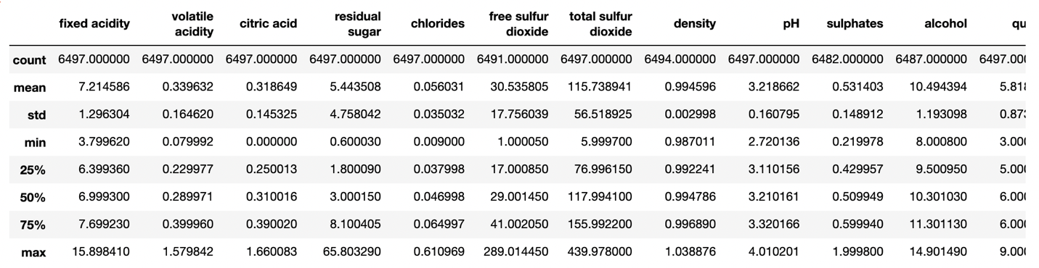

There are no attributes with ‘Zero’ standard deviation. Hence, there is no need to drop any rows at this point of time.

Describing data for ‘Red Wine’ and ‘White Wine’ separately.

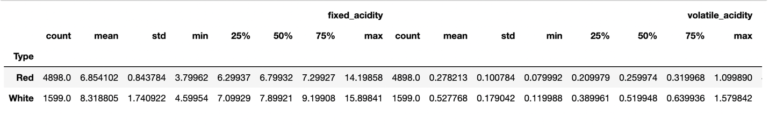

Below are the points which can be inferred:

1. We find that mean quality score of Red wine is 5.87 and that of White wine 5.63
2. There are some significant differences between Red Wine and White wine as mentioned below:   
   a) White wine has higher average fixed acidity, volatile acidity, chlorides, pH and sulphates than Red wine.

We can remove the duplicate rows and the data will be reduced.

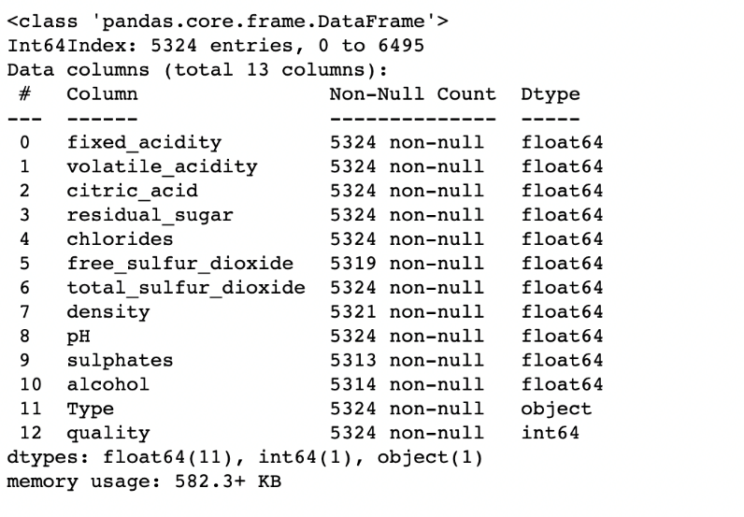

The data has been reduced to 5324 rows after removing the duplicates.

**Rating quality based on range:**

Let us the consider, Quality which is equal or above 7 as Outstanding (Represented by 0),

quality in between 4 and 6 inclusive as a good quality wine (Represented by 1) and wines of quality below 4 as bad wines (Represented by 2) by creating a separate column for rating.

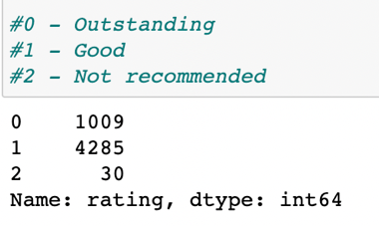

Above picture shows us the number of wines available in the given dataset for each rating.

**3.1 Bar Plots, Histograms, and Inferences:**

To depict the ratio of No. of red wines and white wines in the dataset, let us plot a bar chart.

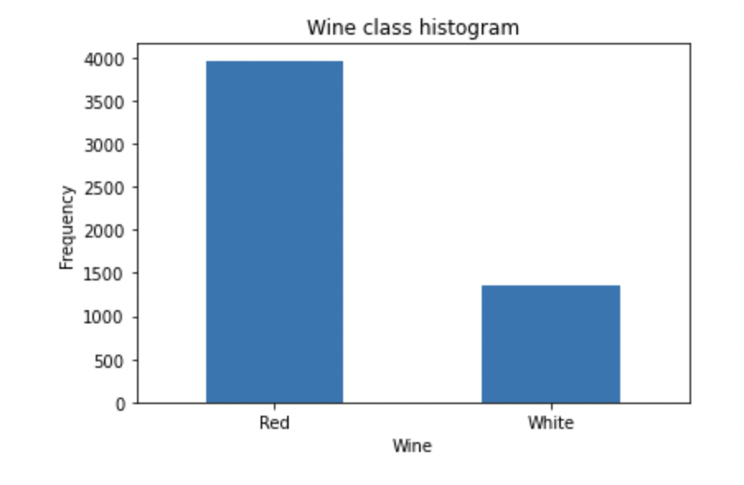

It can be inferred from the above a bar chart that White wine and Red wine are approximately in 1:4 ratio.

Below a bar chart depicts the range of qualities and no of wines available in the dataset for each quality

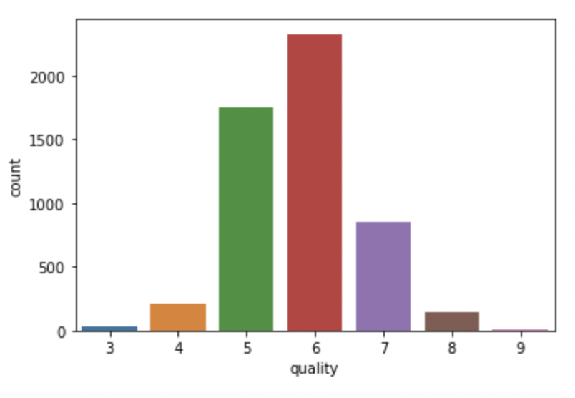

* We can infer from above figure that range of qualities of wine is 3-9.
* Most of the wines are of quality 6 which is a Good type of quality.

Let us also depict a graph for Rating and count of wines in each rating.

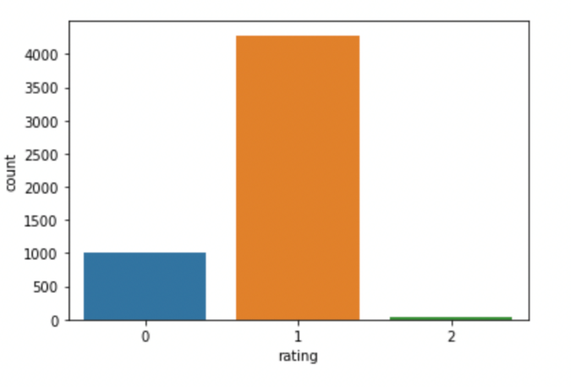 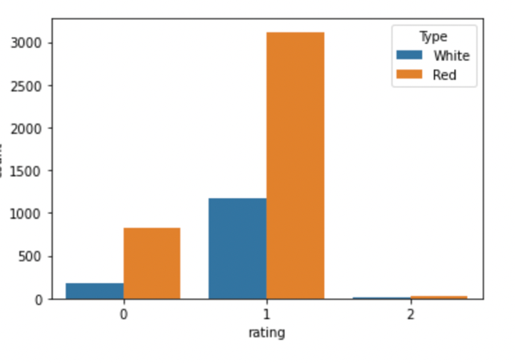

* From first figure we can understand that most of the wines are Good quality wines.
* From the second figure we can understand that most of the good rated and outstanding wines in the given data set are Red wines.
* Whereas bad wines are of almost equal number in both red and white wines.

Bar chart of each attribute are plotted against quality in order to know what values can make changes in quality

For example: below is the bar chart of alcohol Vs quality

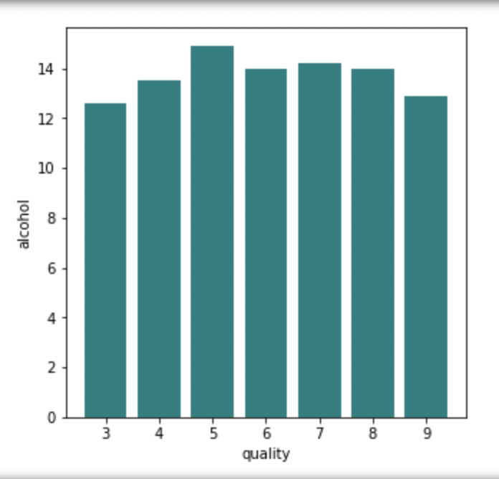

We can check how the quality of wine increases with increase the percent of alcohol in the wine.

Below are the histograms plotted for each attribute and they show us how the data is distributed on features.

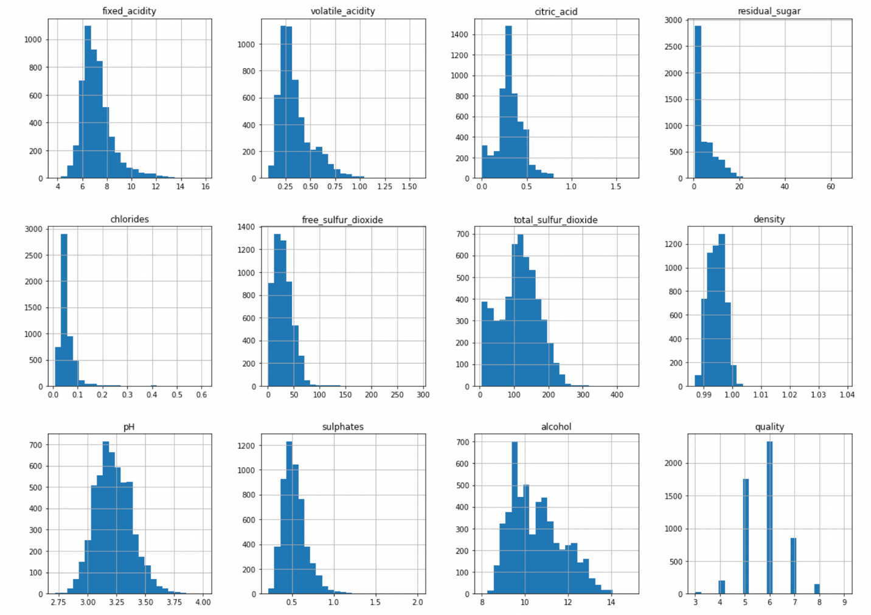

*From the above fig., most of the attributes are normally distributed and right skewed.*

### **3.2 Heatmap, Scatter Plots and Inferences**:

We use the heatmap to find what features are correlated with each other.

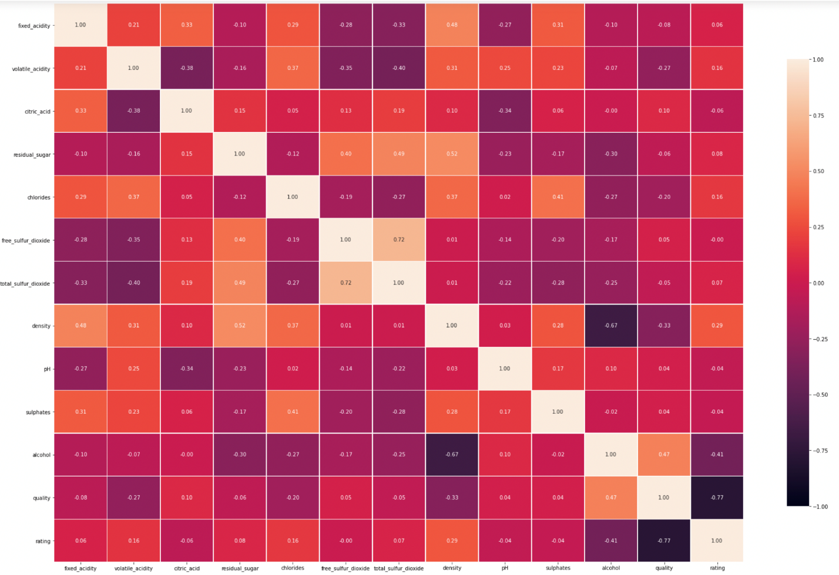

* *Maximum Positive correlation is in between Total and Free Sulfur dioxide i.e., 0.72 (One column can be dropped)*
* *Maximum negative correlation is in between Alcohol-Density i.e., 0.67*
* *Correlation between Quality and rating can be ignored as rating is inserted by us based on values in Quality*

Scatter plot for both Red and White wine:

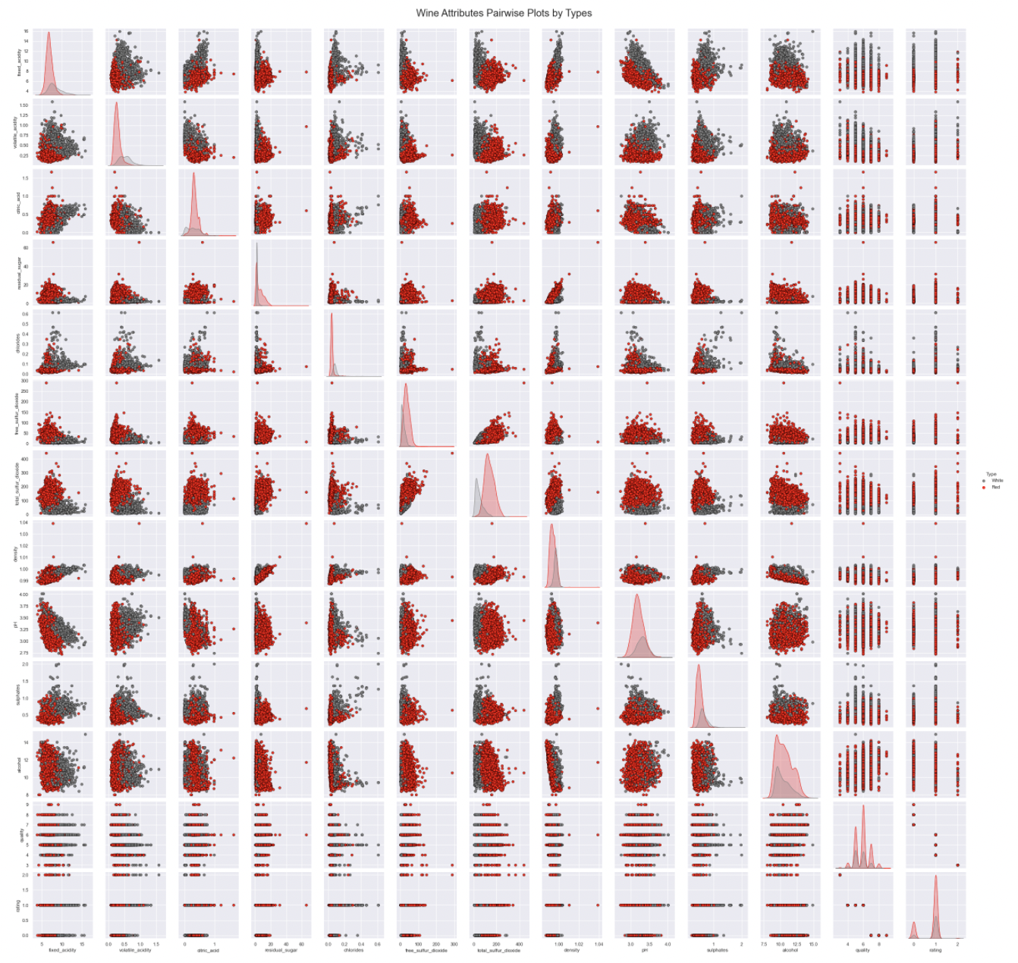

### *From the above Correlation plot and Scatter plot we can infer that:*

* We have inverse relationships between pH and fixed acidity, and it is the same in case of citric acid and volatile acidity.
* We have a strong positive relationship between free sulfur dioxide and total sulfur dioxide.
* Sugar content in the wine may represent the wine density in both the wines.
* Low density contents are high on alcohol content.

We can drop one of the columns among Total and Free sulphuric acid as their correlation value is greater than 0.7.

Dataset information after dropping column ‘Total_Sulphuric_Acid’ is as follows.

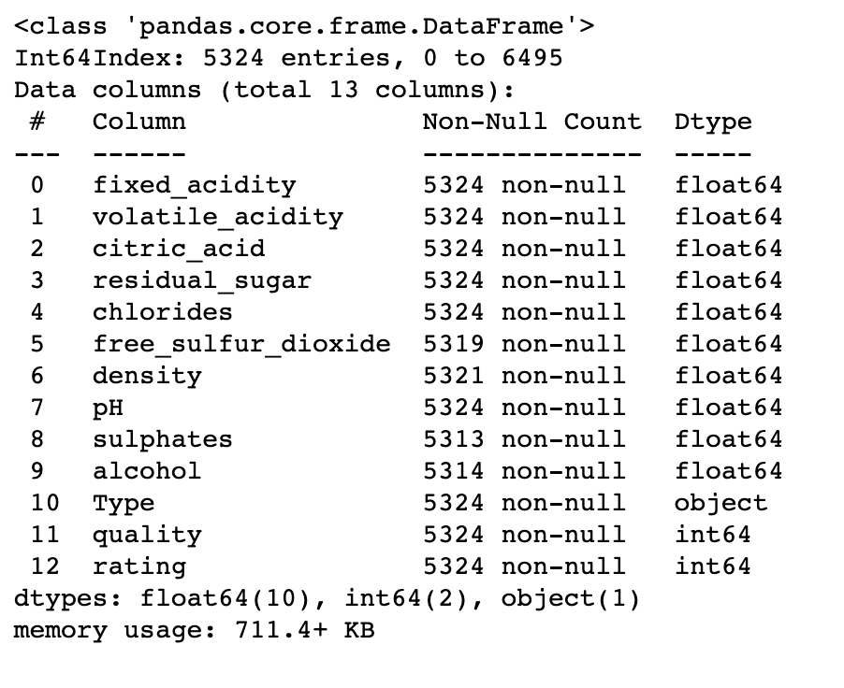

## **3.3 Detecting Missing Values:**

The data seems to be clean by looking at first few rows but let us further check if there are any missing values.

## Checking if there are any values missing with the help of heatmap.

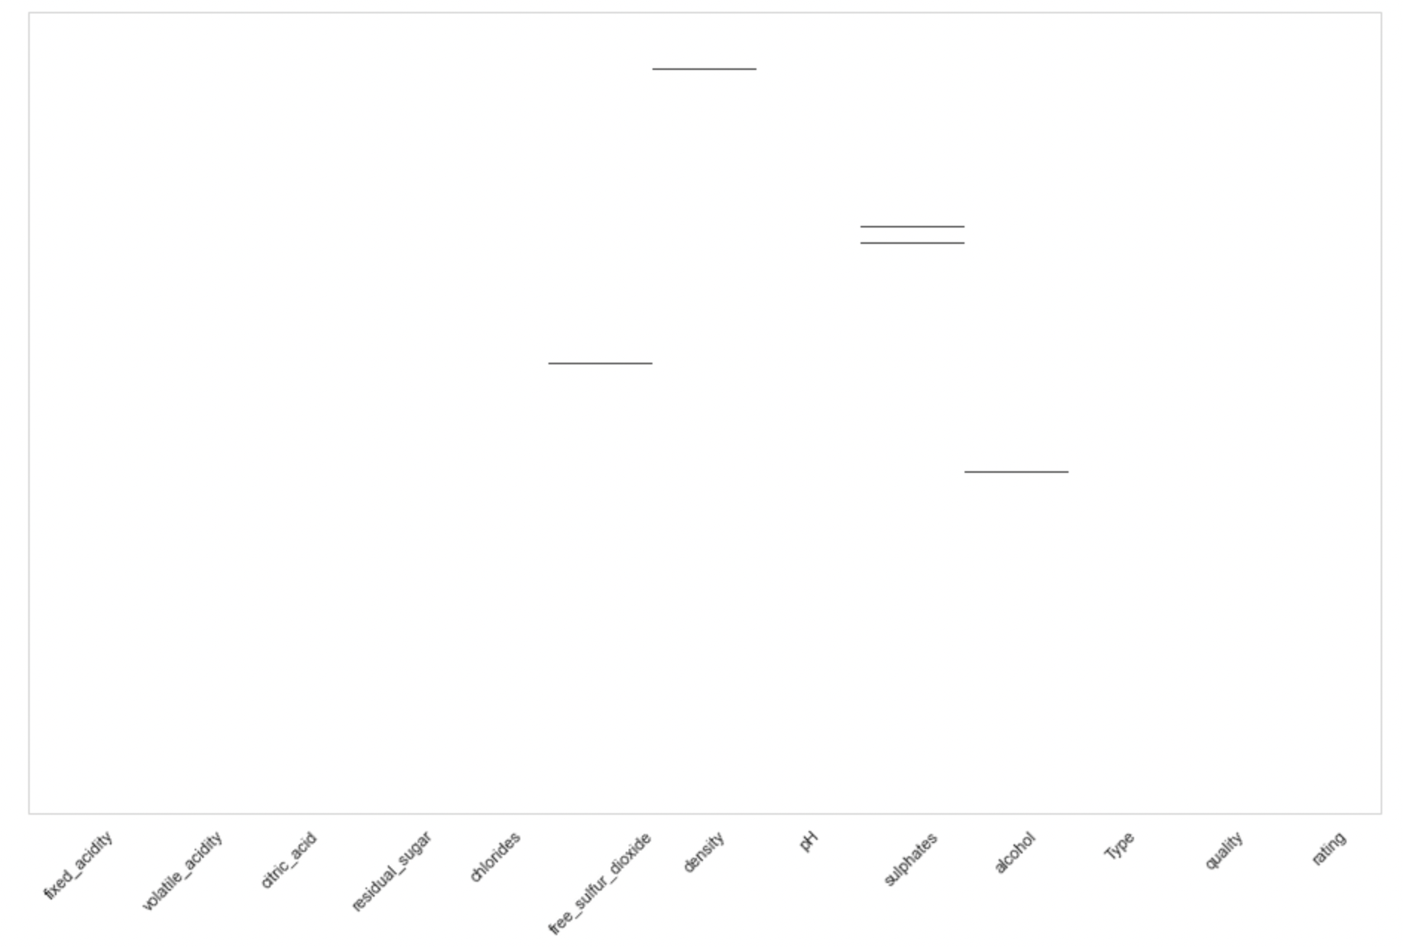

Calculating No.of missing values:

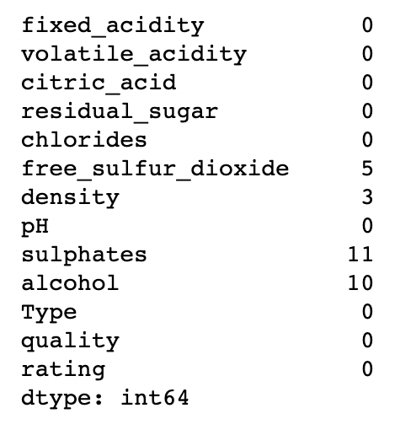

We have:

5 missed values in 'free sulfur dioxide' attribute.

3 missed values in 'density' attribute.

11 missed values in 'sulphates' attribute.

10 missed values in 'alcohol' attribute.

**4. Data Preparation:**

**4.1 Imputing NULL Values:**

As we have missing values, let us impute values into null values using data Imputer. Below is the screenshot of dataset info() after imputing. Object type values are imputed with most frequent values and other types are imputed with mean.

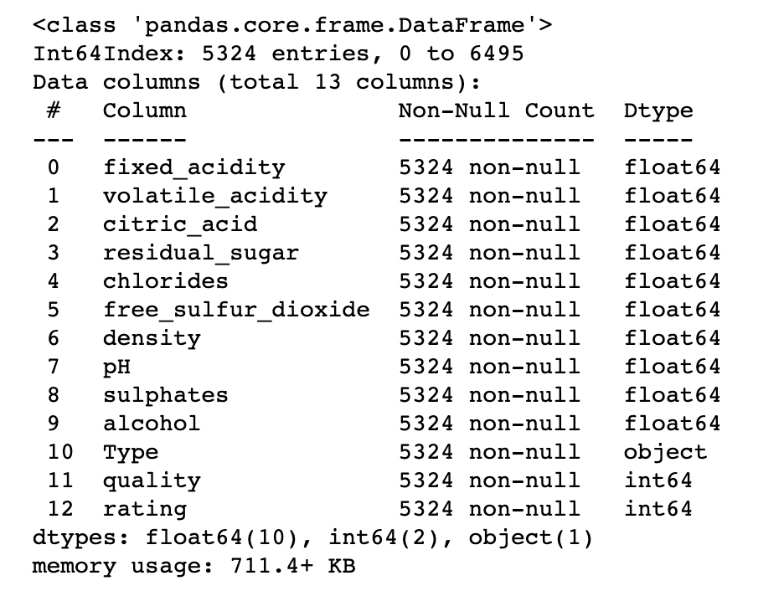

## **4.2 Detecting Outliers and Imputing:**

## **Outliers are the extreme values that deviates from the other observations in the dataset.**

## **We are detecting outliers for each attribute using boxplot.**

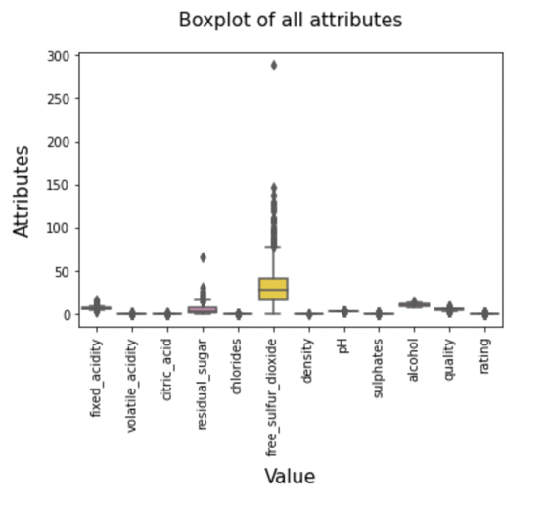

*According to above boxplot most of the outliers are present in Free_Sulphur_Dioxide, Residual_Sugar*

Checking the outlier values for Residual_Sugar and Free_Sulphur_Dioxide

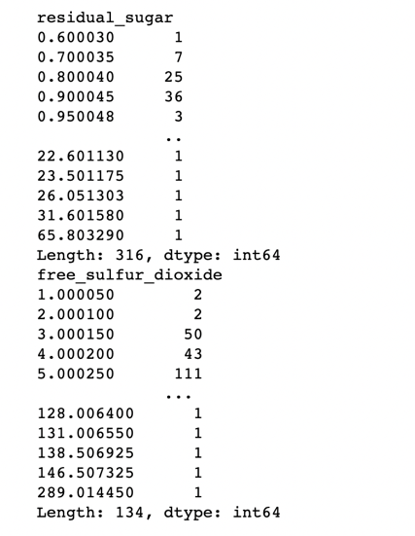

According to the above image, outlier values for Residual_Sugar are in between 20 and 66

And outlier values for Free_Sulphur_Dioxide are in between 120 and 290 approximately.

In order to remove the outliers, we need to replace the outliers with null values first and then impute the null values. We are first detecting the outliers which are above and below quartile range and imputing them with null values. Then imputing the null values using KNN imputer.

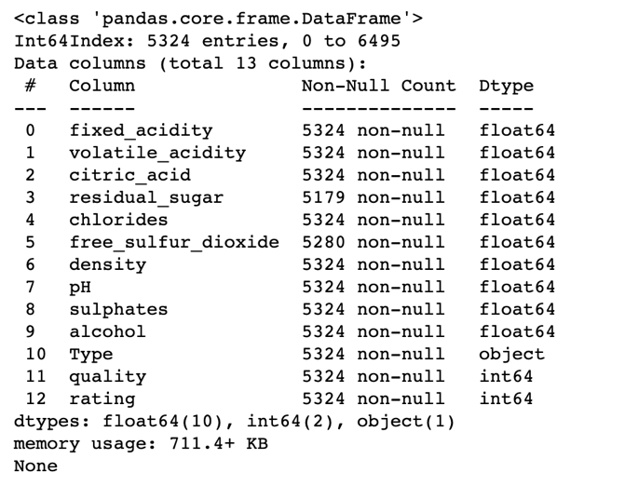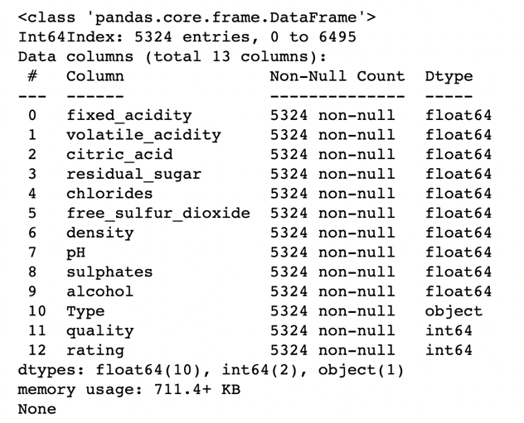The above tables show us the info of the dataset before and after imputing the null values in the positions of outliers. We can see that there are few values missing before imputing in ‘Residual Sugar’ and ‘Free Sulphur Dioxide’ columns.

Now, we are creating dummy variable for object datatypes. We have only one object type attribute here i.e., ‘Type’. We are creating a new attribute named ‘Type_New’ with values 1,0 while 1 represent ‘Red’ type of wines and ‘0’ representing ‘White’ type of wines and dropping column ‘Type’

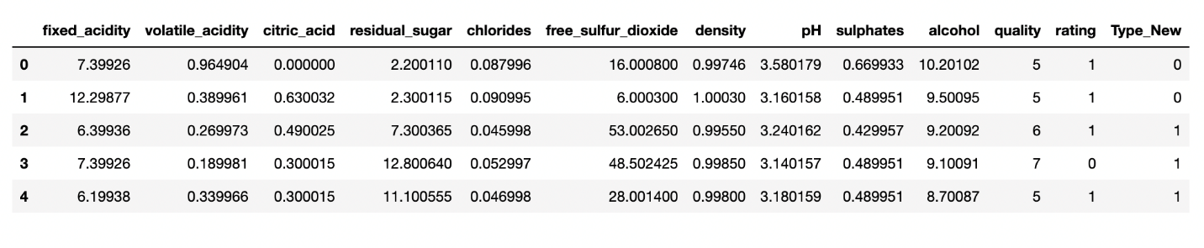

Here, is the first few rows of the dataset after adding a new column ‘Type_New’ and dropping column ‘Type’.

**4.3 Principal Component Analysis (PCA):**

PCA is used to explore large datasets. It helps in reducing number of variables in the data without losing important information. It reduces the dimension of the data by combining highly correlated variables together to form a smaller number of artificial set of variables called ‘Principal Components’ that account for most variance of the data.

Before performing PCA, we need to scale the data into the range 0-1. We are using MinMax scaler from sklearn to scale the data. Below is the dataset after scaling the data.

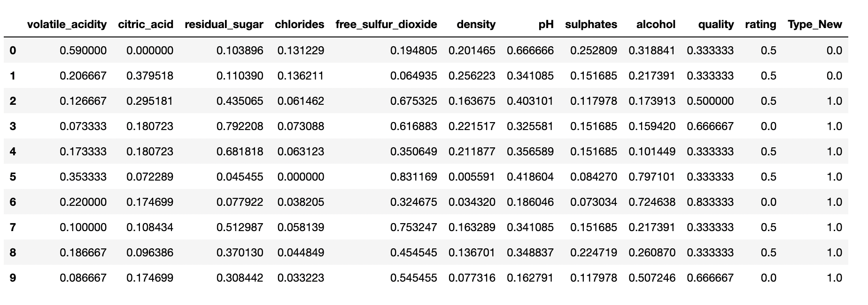

**Explained Variance:** It is the variance explained by each of the Principal Component.

**Explained Variance Ratio:** It is the percentage of Explained Variance that is attributed by selected Principal Component.

**Cumulative Proportion:** It is the accumulated amount of explained variance. For example, if the first 10 PCs are considered around 95% of total variance of data would be accounted.

We are now calculating Explained Variance, Explained Variance Ratio and Cumulative proportion for each Principal Component.

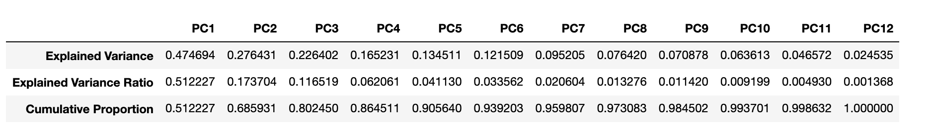

*As we can see from above fig., that around 94% percent of the total variance can be accounted in first 6 Principal Components.*

**Scree Plot:** It is a graphical tool that is used to identify the number of Principal Components to be considered in Principal Component Analysis.

**Elbow point:** The point where Eigen values seem level off is called an elbow point. Components before the elbow point are considered for analysis.

In order to plot a scree plot, we have Components on X-axis and Explained variance on the Y-axis.

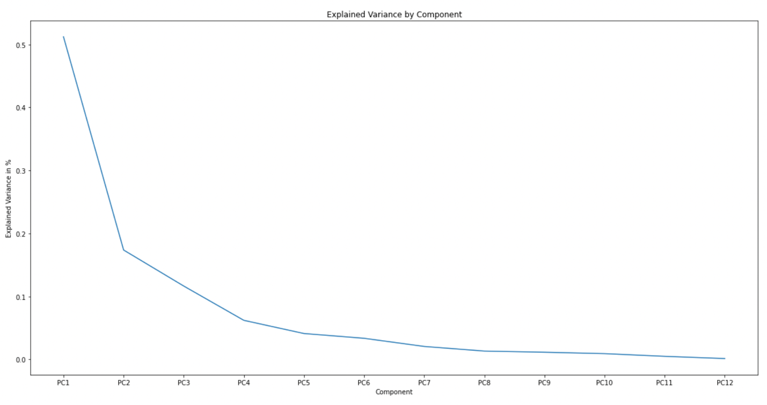

*We can see that there are four PCs before the elbow point. From the above fig., PC 1,2,3 and 4 are enough to describe the data.*

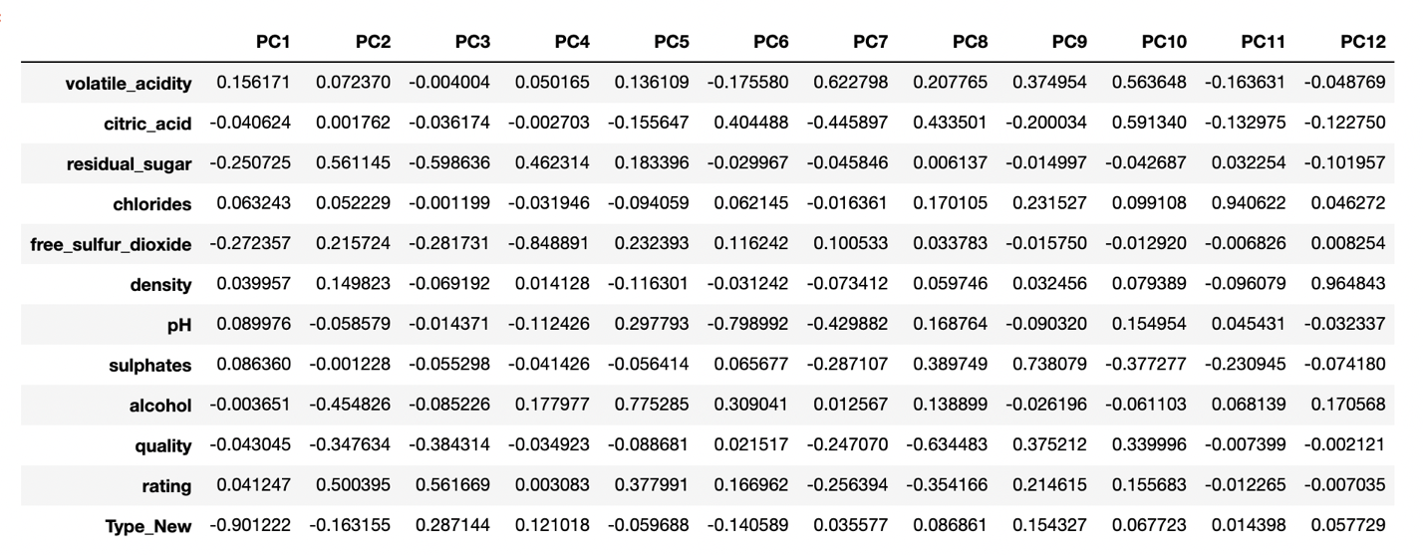

*Above table represent how much does each attribute contribute to each component.*

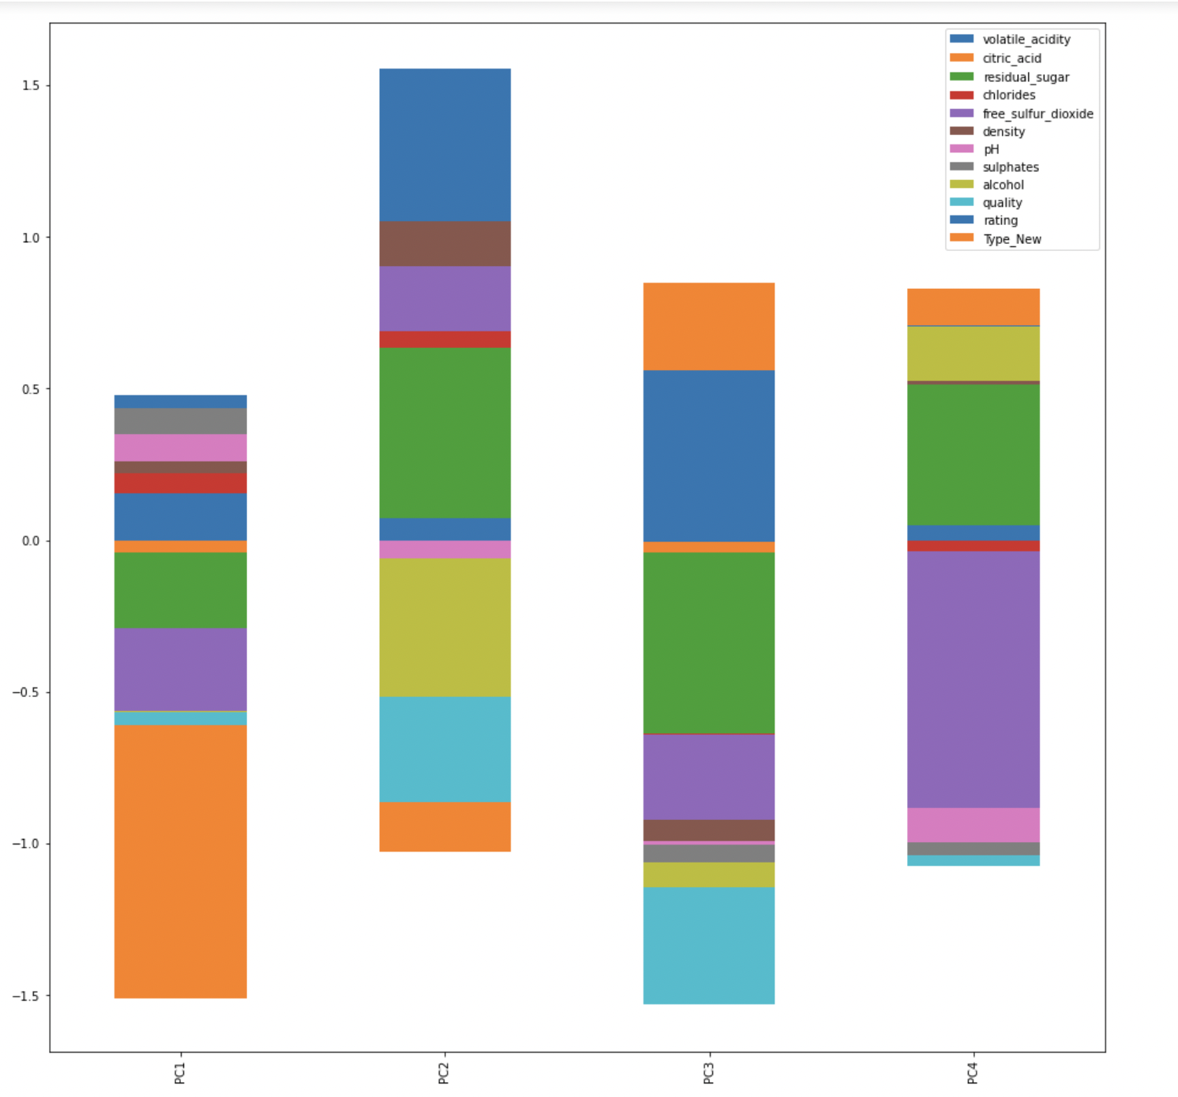

### *Above fig., is a graphical representation of percentage of attributes in each component.*

### *Analysing the features represented by each component:*

#### **For Component 1**

* *Type_New*
* *Free Sulphur Diaoxide*
* *Residual Sugar*

#### **For Component 2**

* *Volatile acidity*
* *Residual Sugar*
* *Alcohol*

#### **For Component 3**

* *Volatile acidity*
* *Residual Sugar*
* *Quality*

#### **For Component 4**

* *Free Sulphur Dioxide*
* *Residual Sugar*

**Score Plot:** It plots the projection of the data on to the PCs in two dimensions. The 'score' of each individual PC is a new 'measurement' that combines all the original physical measurements.

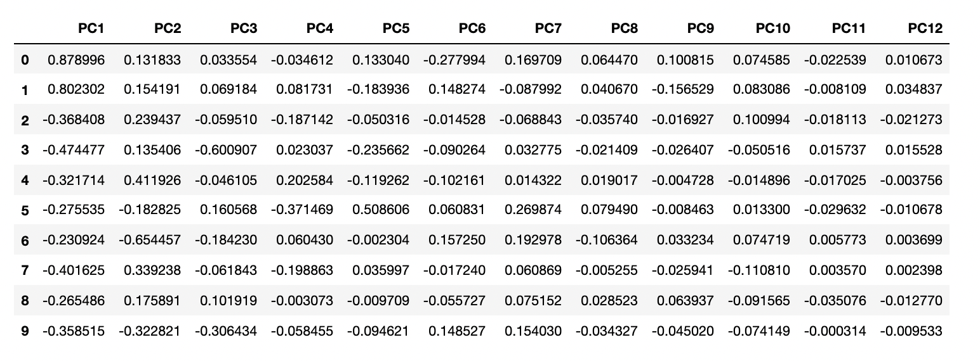

**Score Plot:** It plots the projection of the data on to the PCs in two dimensions. The 'score' of each individual PC is a new 'measurement' that combines all the original physical measurements.



*Above table, shows us the scores of each component.*

*Scatter plot of scores for first two components*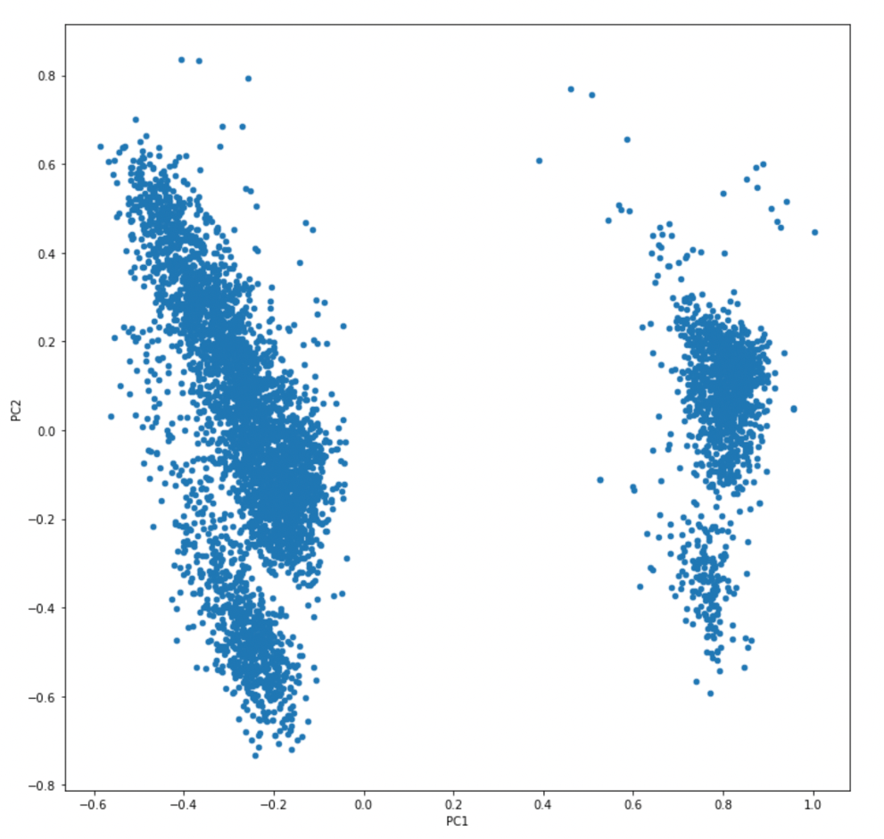.

### **Silhouette Score:**

* A method that calculates the average distance of each point from all other points in a cluster, and then compares that value with the average distance to every point in every other cluster.
* ranges from −1 to +1, where a high value indicates that the object is well matched to its own cluster and poorly matched to neighboring clusters

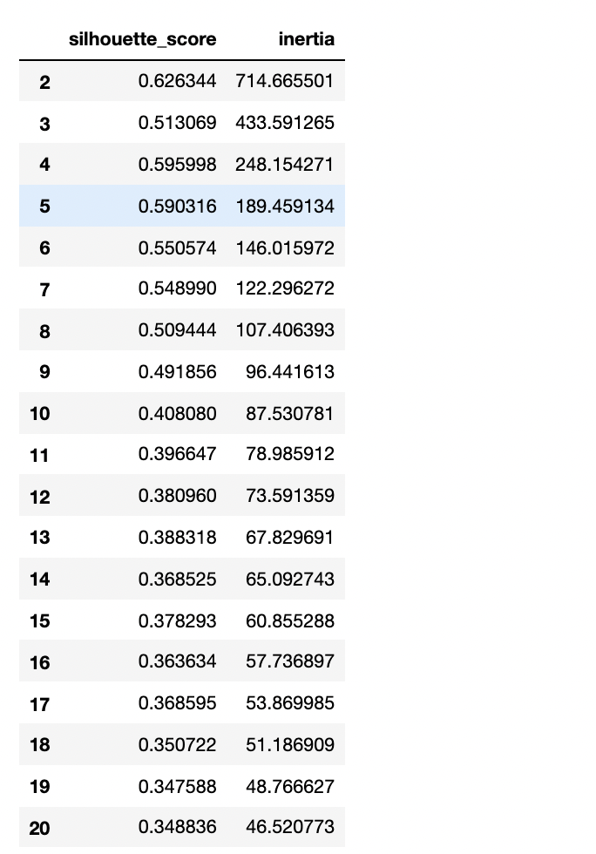**Inertia:** Inertia is a measurement of how well a dataset was clustered by K-Means.

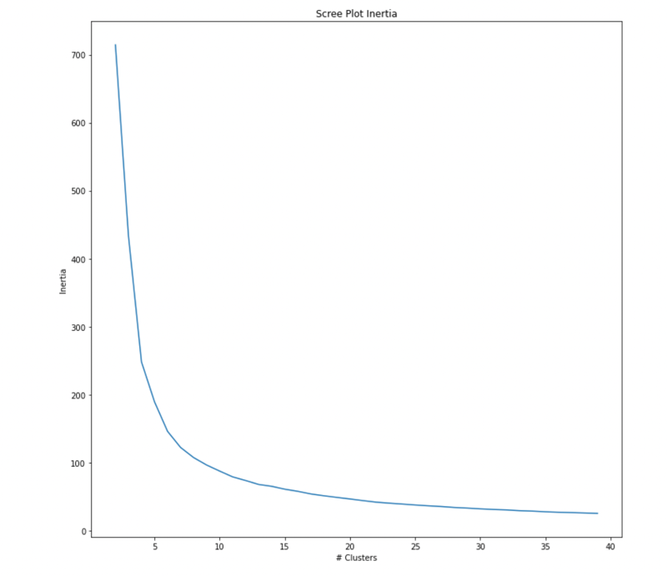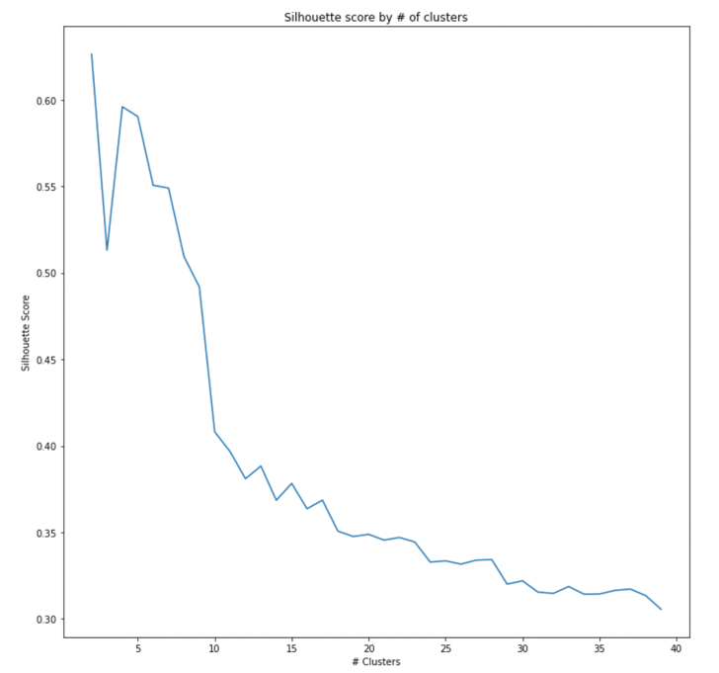*Above table displays few of the Silhouette scores and Inertias*

*Above plots are the scree plots of Clusters Vs Inertia and Silhouette scores.*

### **4.4 K-Means Clustering:**

K-means is the go-to technique for clustering data, with multiple variants of the algorithm for different applications. It's an unsupervised learning technique, commonly used when you do not have predefined classes, and want to understand how, or if, your data is grouped.

* It groups the similar data points together and discover underlying patterns.
* K-means allocates every data point to the nearest cluster
* The ‘means’ in the K-means refers to averaging of the data; that is, finding the centroid.

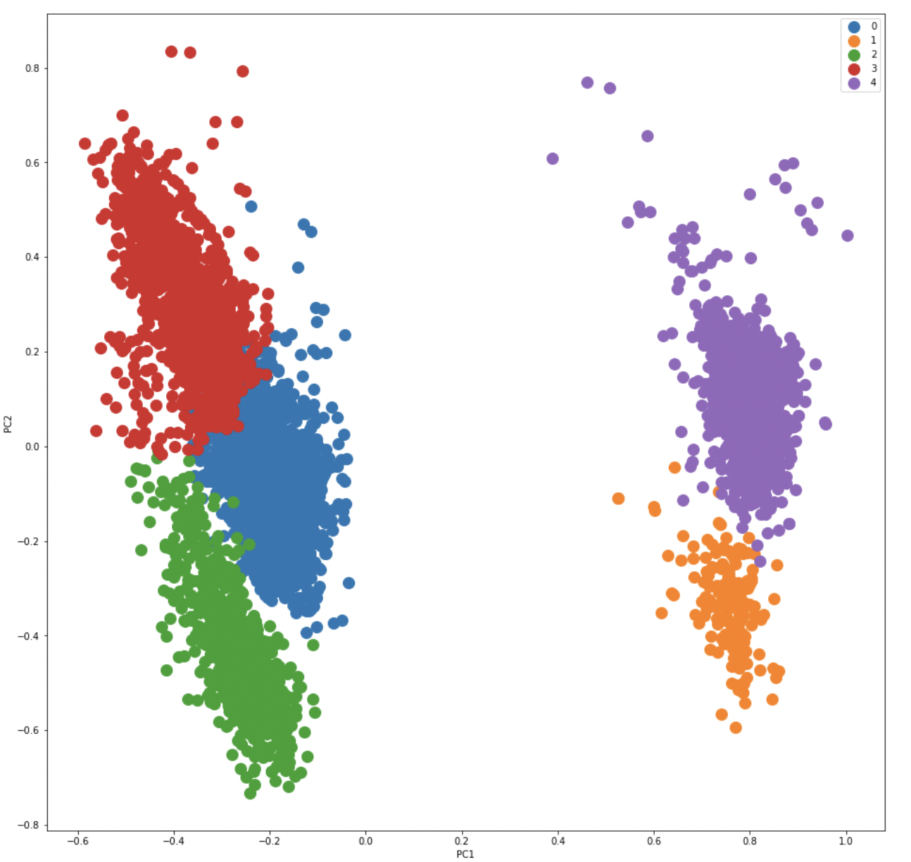

*Above fig., represents the 5 clusters formed by the first two Principal components.*

### **4.5 Handling Imbalanced data**

### Imbalanced classification involves developing predictive models on classification datasets that have a severe class imbalance.

### The challenge of working with imbalanced datasets is that most machine learning techniques will ignore, and in turn have poor performance on, the minority class, although typically it is performance on the minority class that is most important.

### One approach to addressing imbalanced datasets is to oversample the minority class. The simplest approach involves duplicating examples in the minority class, although these examples don’t add any new information to the model. Instead, new examples can be synthesized from the existing examples. This is a type of data augmentation for the minority class and is referred to as the Synthetic Minority Oversampling Technique, or SMOTE for short.

We performed SMOTE algorithm to handle the unbalanced dataset. Below is the source link for SMOTE.

<https://www.kaggle.com/qianchao/smote-with-imbalance-data>

### **4.6 Data Splitting:**

The train-test split is a procedure which is used to estimate the performance of machine learning algorithms when they are used to make predictions on data not used to train the model.

* **Train Dataset**: Used to fit the machine learning model.
* **Test Dataset**: Used to evaluate the fit machine learning model.

In this procedure we take the dataset and split it into two subsets. First subset is used to fit the model and is considered as a Train Dataset. Second subset is used to evaluate the fit machine learning model and is considered as Test dataset.

In our project, we split the data set in the ratio of 7:3 which is 70% of the data is Training and remaining 30% is of Testing.

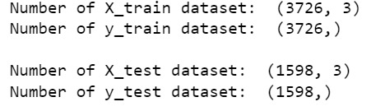

**5. Modeling:**

Data modelling is used to produce a descriptive diagram of relationship between types of information stored in database. Its goal is to create efficient method of storing information while still providing for complete access and reporting.

**5.1 Pipelines:**

Pipelines are used to chain multiple estimators into one and hence, automate the machine learning process. This is extremely useful as there are often a fixed sequence of steps in processing the data.

They operate by enabling a sequence of data to be transformed and correlated together in a model that can be tested and evaluated to achieve an outcome, whether positive or negative.

The main objective of having a proper pipeline for any ML model is to exercise control over it. A well-organized pipeline makes the implementation more flexible.

A pipeline consists of a sequence of components which are a compilation of computations. Data is sent through these components and is manipulated with the help of computation.

**5.2 Classification for Wine Type:**

Classification is about determining a (categorial) class (or label) for an element in a dataset. A classifier is also constructed from a training set composed of the records of databases and their corresponding class names.

We are classifying Wine Type- Red or White, using Logistic regression, Decision Tree and Random Forest.

**5.2.1 Logistic regression:**

Logistic regression, despite its name, is a classification algorithm rather than regression algorithm. Based on a given set of independent variables, it is used to estimate discrete value (0 or 1, yes/no, true/false).

**5.2.2 Decision Tree:**

Decisions tress (DTs) are the most powerful non-parametric supervised learning method. They can be used for the classification and regression tasks. The main goal of DTs is to create a model predicting target variable value by learning simple decision rules deduced from the data features. Decision trees have two main entities; one is root node, where the data splits, and other is decision nodes or leaves, where we got final output.

**5.2.2 Random Forest:**

A random forest is a machine learning technique that’s used to solve regression and classification problems. It utilizes ensemble learning, which is a technique that combines many classifiers to provide solutions to complex problems.

A random forest algorithm consists of many decision trees. The ‘forest’ generated by the random forest algorithm is trained through bagging or bootstrap aggregating. Bagging is an ensemble meta-algorithm that improves the accuracy of machine learning algorithms.

The (random forest) algorithm establishes the outcome based on the predictions of the decision trees. It predicts by taking the average or mean of the output from various trees. Increasing the number of trees increases the precision of the outcome.

A random forest eradicates the limitations of a decision tree algorithm. It reduces the overfitting of datasets and increases precision. It generates predictions without requiring many configurations in packages (like scikit-learn).

*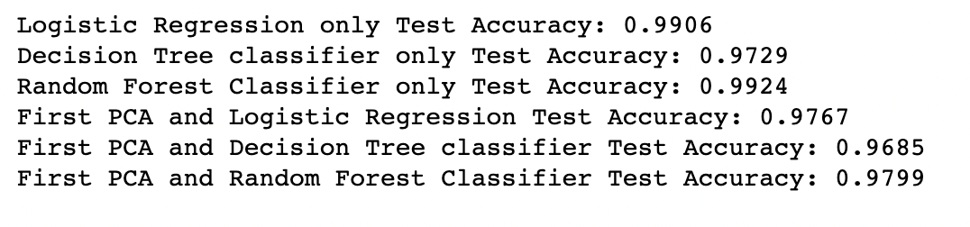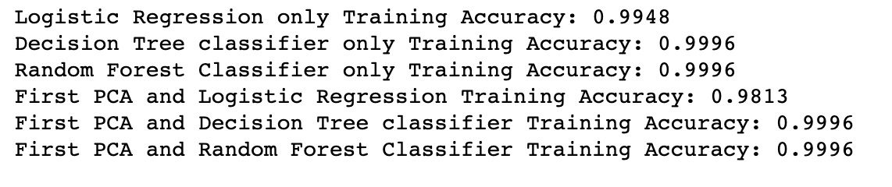Training and test accuracy of all the above-mentioned models:*

*Performance matrix of the Best algorithm Logistic regression and Randon forest without PCA:*

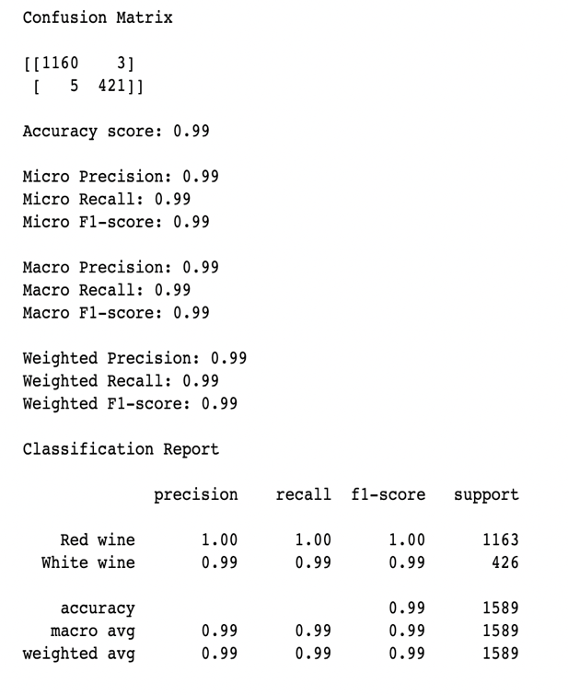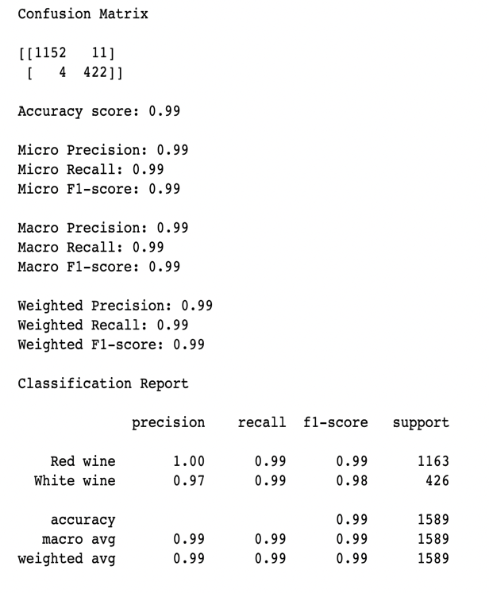

**5.3 Prediction for Wine Quality:**

Prediction is used to analyze past events or instances in the right sequence to predict a future event.

**5.3.1 Linear regression:**

Linear regression has a continuous dependent variable and one or more continuous and discrete independent variables.

Quality is the dependent variable in our dataset, whereas the predictors ('fixed acidity,'volatile acidity,'citric acid,'residual sugar,'chlorides,'free sulfur dioxide,'total sulfur dioxide,'density,'pH,'sulphates,'alcohol') are the independent variables.

As we all know, Linear Regression is quite sensitive to outliers, which we addressed by employing several scaling approaches.

**5.3.2 Ridge regression:**

Ridge regression or Tikhonov regularization is the regularization technique that performs L2 regularization. It modifies the loss function by adding the penalty (shrinkage quantity) equivalent to the square of the magnitude of coefficients.

**5.3.3 Lasso regression:**

LASSO is the regularisation technique that performs L1 regularisation. It modifies the loss function by adding the penalty (shrinkage quantity) equivalent to the summation of the absolute value of coefficients.

Below is the pipeline code showing all regression models:

*Above fig., shows the sample code of Pipeline* 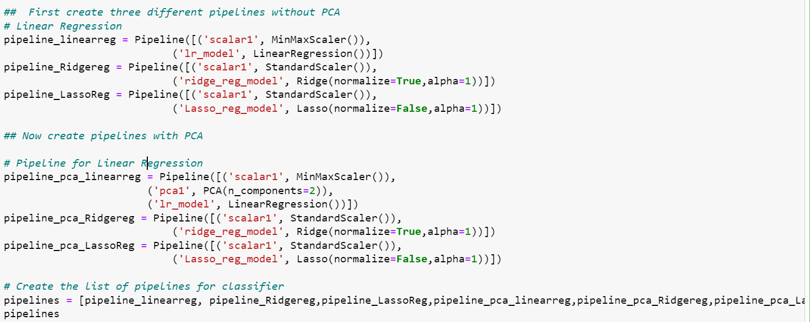

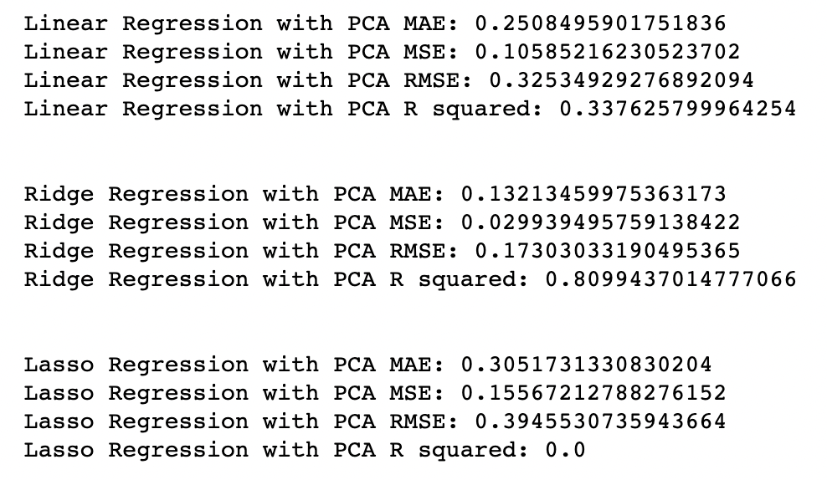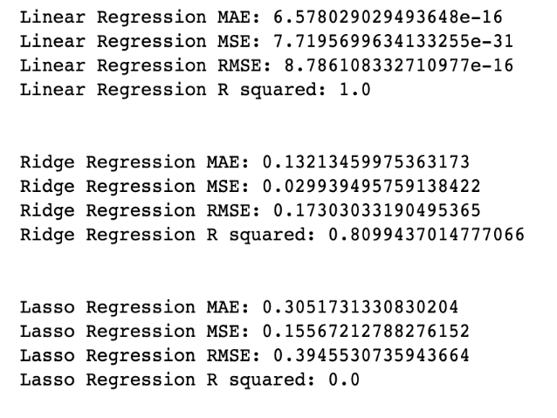

*Above figures shows us the accuracy values for different models with and without PCA*

We conclude that Linear Regression provides the best accuracy after fitting the dataset into various Regression Models.

Following are the accuracies for various regression models for the training Data:

Linear Regression Training Accuracy: 1.0

Ridge Regression Training Accuracy: 0.8099

Linear Regression with PCA Training Accuracy: 0.3376

Ridge Regression with PCA Training Accuracy: 0.8099

For the Test Data:

Linear Regression Test Accuracy: 1.0

Ridge Regression Test Accuracy: 0.8077

Linear Regression with PCA Test Accuracy: 0.3199

Ridge Regression with PCA Test Accuracy: 0.8077

**6. Conclusion:**

We have achieved our goal by getting good models were able to create classification models for type and prediction models for quality of the wine going through all phases in a standard Machine Learning and data mining workflow models.

We obtained good insights in the Data exploration phase and identifies and treated multiple problems.

We conclude that it is possible to predict the quality of a wine and classify its type from the physical chemicals attributes.

**Wine Quality prediction:**

After applying different regression models, based on the accuracy and other outputs, we can say that we achieved accuracy of 80.77% for Ridge Regression model.

**Wine Type classification:**

After applying different classification models, based on the accuracy and other outputs, we can say that we achieved accuracy of 99% for both Logistic Regression model and Random Forest.

Both Logistic regression and Random forest works equally well but we decided to use the logistic regression as it is simple compared to random forest.